**Databases for Data Science**

**Homework 3**

**Provide answers to the following questions as a single PDF or Word file:**

**Q1: Convert the ER diagram given at the following web page:**

[**http://www.databaseanswers.org/data_models/airline_reservations/index.htm**](http://www.databaseanswers.org/data_models/airline_reservations/index.htm)

**into a set of tables using the ER2DB methods we saw in class. Use the create table syntax we saw in class. Make any necessary assumptions and note them in your answers.**

**Q2: Convert the ER diagram given at the following web page:** [**https://www.flickr.com/photos/ikhnaton2/533233247**](https://www.flickr.com/photos/ikhnaton2/533233247)

**into a set of tables using the ER2DB methods we saw in class. Use the create table syntax we saw in class. Make any necessary assumptions and note them in your answers.**

**Q3: Convert the following ER diagram into a set of tables using the ER2DB methods we saw in class. Use the create table syntax we saw in class. Make any necessary assumptions and note them in your answers.**

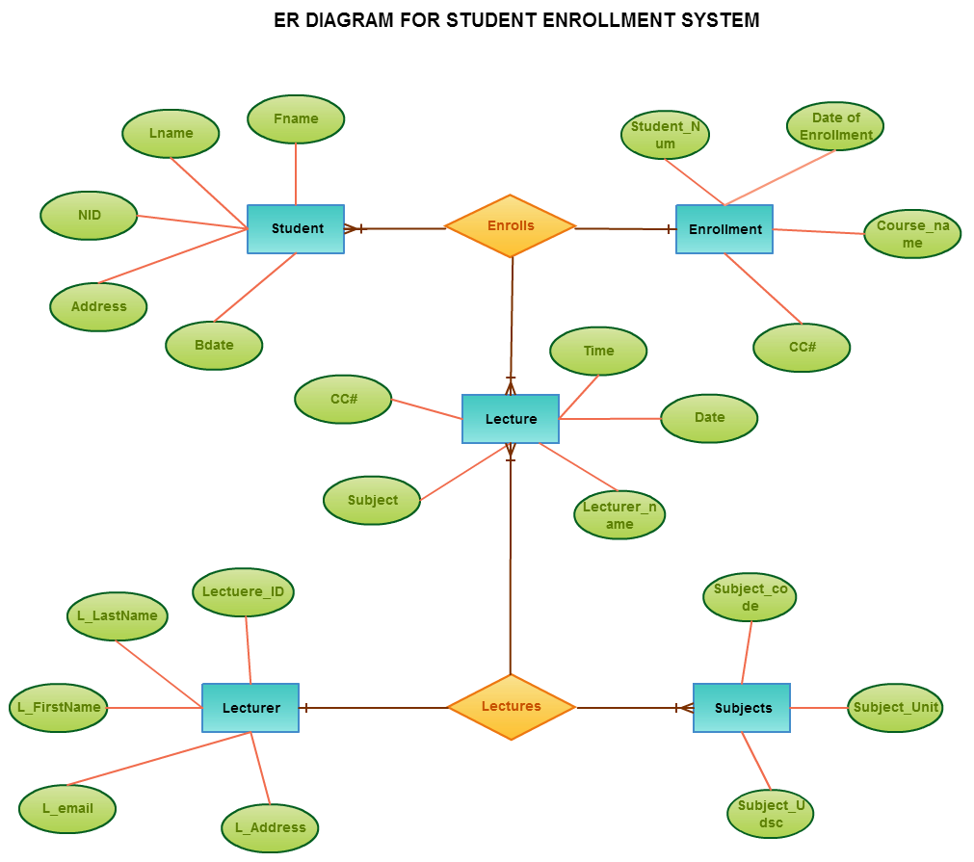

**Q4: Convert the following ER diagram into a set of tables using the ER2DB methods we saw in class. Use the create table syntax we saw in class. Make any necessary assumptions, and note them in your answers.**

